***Registering and Managing your Round***

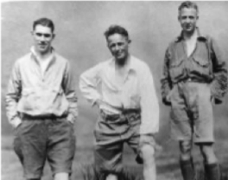

***using the Bob Graham Round Club website***

1. ***Introduction***

Prior to attempting your Bob Graham Round, you should register your Round with The Club.

This creates a unique “**User ID**” that you can then use to:

1. Inform The Club when your attempt is taking place.
2. Calculate potential schedules for your Round.
3. Provide The Club with details of your actual attempt to formally Ratify your Round.

The recently updated version of the website also allows you to “migrate” your details if you previously registered on one of the old versions (see section 7).

In these instructions for the website, you will find the following sections:

* 1. “Please read first!!!” – this section explains a few key things about the website that will help you make the most from it.
  2. “Registering your Round” – use this when you are new to the website and want to first register your planned attempt.
  3. “Managing your Registration” – use this section to update the information about your Round and (ultimately) Ratify your Round (or failure ☹)
  4. “Schedule Calculator” – a guide to the handy Schedule Calculator!
  5. “Ratifying your Round” – the process of letting The Club know the details of your successful Round.
  6. “Migrate an old Registration” – this section shows you how to migrate a registration that was made between 2020 and 2023 on the old version of the website.
  7. “Using the website on multiple devices” – explains how to synchronise your data between multiple devices if you want to edit your data on more than one device.

1. ***Please read first!!!***

Here are some key things to know that will help you use the website:

* The site has been designed to “remember you” on the device you register with. You *can* use the BGR Club website from more than one device, but there are some things that you need to be aware of – see section 7 if you intend to use more than one device to manage your registration.
* Once registered, you will receive a unique 10-character User ID (UID). Please use “copy and paste” on your device to make a copy of this for future reference.
* The website includes a handy Schedule Calculator that you can use to plan your Round.
* The website uses cookies. Unless you have explicitly changed your browser settings, you’ll be fine. If however your browser is set to prevent cookies, you’ll need to add the BRG Club website to your list of exceptions.
* If you previously registered with the Bob Graham Round Club website before 2019 you will need to “start from scratch” and set yourself up as a new user on the system.
* If you previously registered with the Bob Graham Round Club website between 2020 and 2023 (and have a 10-character User ID), you can migrate your details to the new system (see section 7).

1. ***Registering your Round***

To register your Round with The Club, follow the steps below. Your life will be made easier if you do this on what you consider to be your **primary device**, ie the PC / tablet / mobile that you use most often. The steps:

1. Visit the webpage <http://bobgrahamclub.org.uk/index.php?page=register>

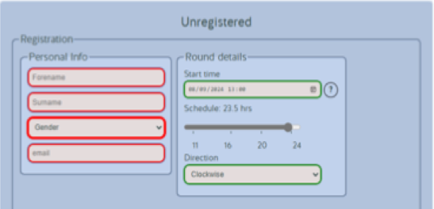

1. Go the bottom of the page and select Option 4 from the drop-down menu
2. Enter the requested information. The Round details you enter at registration are not “set in stone” – you can change these later by “Managing your Registration”).
3. Click the Register button. (You cannot submit the form if any field has a red border.)

That’s it, you are registered! Please note your unique 10-character User ID (UID).

And just in case you wondered, you currently do **NOT** receive an acknowledgement email from The Club.

Other notes:

* The system will only allow start times on the quarter hours, i.e. 00, 15, 30 or 45 minutes past the hour.
* A time of midnight (00:00) means the very start of the day, i.e. 00:00 is the first minute of Saturday, not the last minute of Friday.
* You may only pick a start date between the current date and the 31st of December of next year.
* Fields will have a red border until they contain valid data.
* The system helpfully shows the phase of the moon and daylight hours for your proposed date, time and schedule.
* It also shows you if there are other people registered to start in the same 48-hour period as you, i.e. plus or minus 24 hours from your proposed start. Your chosen start time is indicated in the list with an *.
* **Important! Having registered, it’s your responsibility to manage the details of your attempt and ultimately inform the club of how things went. This is done via the “Manage your Registration” page (see next section).**

1. ***Managing your Registration***

Once you are registered, you may need to update the details of your Round or cancel your attempt. Hopefully you will ultimately have a successful Round and want to ratify your achievement and gain membership of The Club! These tasks may be undertaken from the “Managing your Registration” section of the website.

To manage your registration, login to the website. You may already be logged on your device from before, in which case just click on the “Manage your Registration” menu option. Otherwise, you’ll need to login:

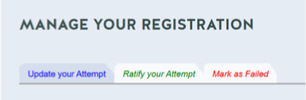

1. Click on the “Login” button in the top right of the BGR Club home screen. (If you are already logged in, the login button is hidden.)
2. Fill in your User ID and email address.
3. Click “Submit”.

Once on the “Manage your Registration” page you can use the simple form to update your Round details, e.g. your proposed start date / time:

* Update the form as required.

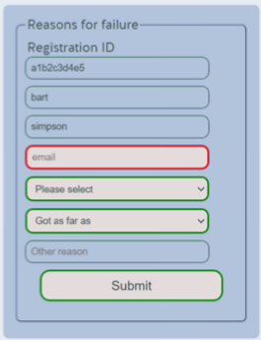

* Click “Save details” to save the changes.

You can also notify The Club if you fail your attempt (and don’t plan to re-attempt this year) or wish to cancel it.

This option is on the (red) third tab:

* Use the drop down lists to enter your reason for failing (or cancelling) and let The Club know which summit you made it to.
* Click “Submit” to confirm.

The Schedule Calculator and Ratifying your Round are covered in their own sections below.

1. ***The Schedule Calculator***

The Schedule Calculator is a useful tool to help you plan your Round, based on decades of experience from previous Rounds.

To use the Calculator, simply click on the “Schedule Calculator” option from the main site menu.

You will be presented with a form containing a number of options to “tune” your schedule, including the start date/time, how long you will take a break at the road crossings, whether you will visit Sergeant Man or High Raise first during Leg 3, etc, etc. As you make choices from the options, the website will instantly generate a new summit-by-summit schedule based on your selections. The resultant schedule appears at the bottom of the page where you can copy it for your own further use or share it with your support team. In fact, if you print this page, the website will generate a “print-friendly” version of the schedule table for you. Once you are happy with your schedule, don’t forget to press the “Save Schedule" button.

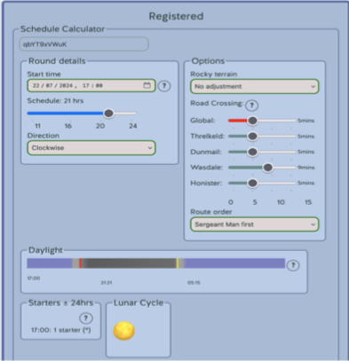

Please note, the Calculator works independently of your formally registered start date/time/schedule, therefore you can experiment with different options on this page without it affecting your formally registered timing. **Note, by saving a schedule, the website does NOT register your attempt with these details!**

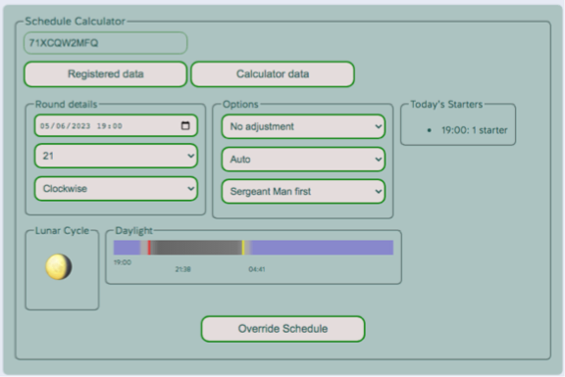

Assuming you are registered and logged in already, you can flip back and forward between your registered schedule and your (experimental) calculated schedule using the buttons at the top of the form.

You can “reset” the calculated schedule back to one based on your registered schedule by clicking the “Override Schedule” button at the bottom of the form.

1. ***Ratifying your Round***

If you are reading this section of the instructions, congratulations on your successful Round! If it was your first success, welcome to The Bob Graham Round Club, “the most exclusive in the world……”! We hope you had a great time on your Round and look forward to seeing you at the next Presentation Dinner.

One of the aims behind the ratification form is to make the process of submitting your ratification data as simple, automatic and accurate as possible, but you still need to be careful and have some information to hand before you start filling out the ratification form. The form does a lot of work to try and ensure that the data you enter is valid, complete and consistent.

Firstly, the site itself has basic data about yourself and your round that you already entered when registering. Rather than have to fill this in again, the site looks for as much data as possible and pre-fills those parts of the form.

The site also has listings of existing members, along with some non-members who have helped on successful rounds, that are searched when you enter a membership number or surname to suggest a name or names. This helps you get the right person and also avoid spelling mistakes.

Finally, if you used one, the form accepts timing data from GPS and tracker devices, either via uploading a file or linking to the tracker. The code then does its best to work out your times at each summit.

There is more help in the FAQs below the form itself.

**Preparation**

The site will pre-populate your ratification form with many of the details from your registration, e.g. first and last name, gender, start date, Round direction and so on. You can check and correct these (if needed) as you go through the form. The additional information you will be asked for during ratification is as follows:

* Your age on the day you completed the round.
* Your nationality. The system doesn’t handle dual nationality.
* The BGR Club members you may have supported on Rounds previously, including their membership numbers (*)
* Names of any close family member who are already members of the BGR Club, including their membership numbers (*)
* For UK residents:
  + Your club name (if you have one)
  + Your post code
* The times (in 24-hour clock format) that you visited each summit. You can enter this manually, or as mentioned above, use a .GPX file or link to a tracker. For the tracker option, you’ll need your unique tracker address and tracker ID.
* How long you spent at each of the road crossings
* A list of all your supporters, including what role they took. By role, this means whether they provided road-side or running support, and for runners, which Leg they ran. For supporters who are already BGR Club members, you’ll need their membership numbers (*)

Once you’ve got all this information together, you’re ready to complete the ratification process.

*(*) Membership numbers are issued at the end of each calendar year. Therefore a new club member who completed their Round earlier in the year won’t yet have a membership number. In this case, you can only include their name.*

**Completing the ratification form**

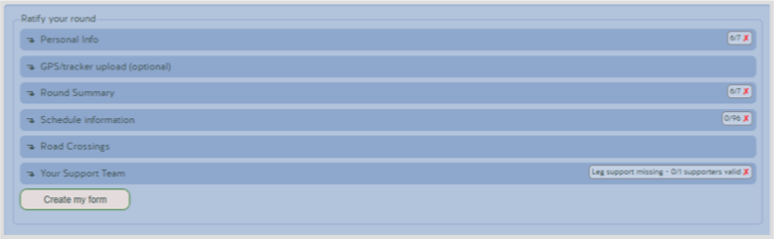

Armed with all your relevant information, all you need to do is step through the sections of the ratification form.

It is easiest to make your way through the sections from top to bottom, although it’s probably worth having a quick preview of each section first. In this way you can see what is expected in each section and check the data that has been automatically pre-populated from your registration. Each section header bar shows the number of required values that have been entered.

Here are brief instructions on how to fill in the sections.

1. **Personal Info**

This section is pretty much self-explanatory and mainly pre-populated from the registration process.

For UK residents:

* Club: please complete in full, no abbreviations or nicknames! The website will make suggestions as you type. Leave empty if you are not a member of a club.
* Postcode: only enter the first part of your postcode please. This is the local post sorting office and is generally one or two letters followed by one or two digits, e.g. CA11.

You only need to fill in the “assisted the following club members” and “related to these club members” lists if they apply to you.

1. **GPS/tracker Upload**

If you used a GPS device or tracker to record your round then this section lets you upload a file or link to the tracker data to automatically fill out your times at each summit. Select from the drop down list, choosing an option will display a set of instructions.

**GPS**: Use the file selection box to load your file. The code will perform several checks and indicate how it handled the file. If you used more than one device, usually because of battery issues, then upload the second GPS file.

**Kong Tracker**: Copy and paste your tracker’s web address - something like **https://live.kongtracking.com/bgr2024/?b=500** into the field then click on the button to retrieve your timings.

**Schedule Calculato**r: This takes your ***planned schedule*** to populate your timings. You can then correct them with your ***actual times***. This is really only useful if you stuck closely to your planned schedule.

You should still scan through the times as the code may have determined that you visited some tops a minute or two either side of your actual time.

1. **Round Summary**

This will be pre-filled with data from your registration along with any changes made on the “Manage your Registration” page.

**Round Type:** should generally be left as “Qualifying” unless you are already a club member and have completed a second (or more) round.

**Completion Date**: this will be automatically filled in if you uploaded a GPX file or tracker data.

**Start Date**: this is filled in with data from your registration. If it’s more than a day different to the Completion Date it will be marked as invalid.

**Previous Attempts**: Defaults to zero but if you have attempted the round before then change to the appropriate figure.

**Guided attempt**: Should be left at “No”. The club does not ratify rounds that use professional guiding services for all or part of the round.

1. **Schedule Information**

This data will already be filled in if you uploaded a GPX file, used tracker data, or used the option to copy from your planned schedule. Please check through the data if you used the automatic process as it isn’t 100% fool-proof.

For those entering this data by hand, the times required are actual times, in 24hr format, not elapsed time. Enter hours in the left hand column, minutes in the right.

1. **Road Crossings**

Will be pre-filled in with times from the calculator if you used that facility or 15 minutes if you didn’t. Adjust to show your actual times.

1. **Your Support Team**

As mentioned above, you will need various bits of information about each member of your support team:

* Name (spelt correctly! Particularly the surname).
* BGR Club membership number, if applicable.
* Whether they have supported a successful round before.
* How they helped: Leg 2, road, etc.

Next, do the following for each supporter.

* 1. Enter their membership number (if they have one and you know it). The name fields will be filled in automatically.
  2. Alternatively enter their surname. Suggested names will appear in a scrollable list, if the individual appears in the list select them - the surname field will auto-complete and the forename field will be filled in automatically. If they are a club member then their membership number will be filled in. Those who have previously helped fewer than five times will not be suggested.
  3. If they have helped on previous rounds ensure the “Previous support” box is checked.
  4. Indicate how they helped by checking the relevant box or boxes. Check all that apply.
  5. Click on “Add another of your support team” and repeat the above steps until you have included all your support.

The code works to prevent certain combinations that don’t make sense, things like: checking any of the “Leg x” boxes disables the “Reciprocal Round” box and vice-versa (reason: a reciprocal round is one where the individual is a non-member and accompanies you on **every** leg.)

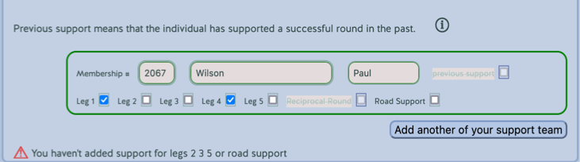

To ensure the form is filled in correctly, you may get warning messages until all the information is complete, e.g. if a surname field is left empty or you forget to tick what role they performed. It will also check to make sure you record a pacer for every leg.

**Submitting your ratification**

Once you are happy that all the data has been filled in correctly, you can create the spreadsheet that is sent to the BGR Club.

When you are ready, click the “Create my Form” button.

In a couple of seconds, the button will change to “Download my form” and be a clickable link. Click on this and the spreadsheet file will be downloaded to your device/computer. (Users of Chrome may have to confirm that they wish to do so as that browser implements extra security features.)

Now start a new email with the subject of “BGR ratification for <your name>“, attach the downloaded spreadsheet file and send the email to [membership@bobgrahamclub.org.uk](mailto:membership@bobgrahamclub.org.uk)

1. ***Migrate an old Registration***

There are two scenarios here:

1. You registered before 2019 and **DO NOT HAVE** a 10-character user ID.
2. You registered between 2020 and 2023 and **DO HAVE** a 10-character user ID (from the previous version of the website).

For scenario 1, unfortunately you will just need to start from scratch and register as a new user on the website, following the process in section 3.

If you do have a User ID then follow these steps:

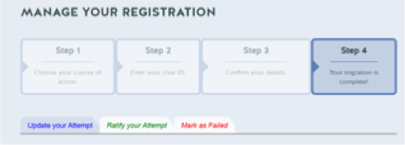

1. Visit this page <http://bobgrahamclub.org.uk/index.php?page=register>
2. Go the bottom of the page and select Option 2 from the drop-down menu.
3. Fill in your email address, User ID and select the year that you registered.
4. Click “Submit”.

The system should now find your details and the page will update to show your migration has completed (see screen shot). For your schedule, it will use the start date / time of your original registration so you will need to update this using the simple form further down the page using the same instructions as per the “Managing my Registration” process.

You are now migrated to the new system and can manage all your future attempts from here.

If your details aren’t found then there’s a couple of possible reasons.

* Perhaps you hadn’t actually registered? If you previously used the Schedule Calculator and saved a schedule, perhaps you thought this meant your Round was then registered too? As mentioned earlier, that’s not how the website works.
* Perhaps you noted your User ID by hand and got one of the characters wrong?

1. ***Using the website on multiple devices***

The way the software works means that your device ***AND*** the website each keep a copy of your registration information. Every time you save your registration data from your primary device (by pressing “Submit”), a copy of it is saved on the BGR Club website. When you do this, both your primary device and the website will be “in synch” with the same data.

When you login from another device the website will send your latest registration data to that second device. If you then change your registration details at all on this second device and save them back to the website (using “Submit”), the data on your primary device will be “out of synch”.

When you next log on from your primary device, the website will spot that the data is now “out of synch”. It will then offer you the choice of either synchronising with the website (and therefore what you saved on the second device) or sticking with the data on your primary device. In most cases you will want to synchronise and use the website copy as “the master” version.

1. ***Appendix***

**GPX Files**

If you've done any orienteering then the way that the code determines when you visited a summit is similar to navigation when orienteering, i.e. you have coarse nav and fine nav. An analogy would be that the coarse nav gets you onto the football pitch, the fine nav gets you to the centre spot.

Something to be aware of, trackers such as those from Opentracking/Kong Running don’t record your position regularly enough to be usable by this system. Opentracking use a one minute interval. The Garmin InReach and SPOT trackers use an even longer interval - either five or ten minutes depending on your account settings. They aren’t meant for such accurate location logging.

**Multiple Files**

Some people use two or more recording devices to ensure that they don’t run out of battery on a single device. Our system only accepts a single GPX file therefore in this case you should upload them one at a time in the correct order, i.e. Start to XXX, XXX to finish.

The first file will result in a message “The file was successfully analysed - but it looks like it only covered part of the route. Please upload the remainder.” This will be replaced when you upload the second file with “The files were successfully analysed…”.

**Trackers**

Allied to GPS devices are GPS trackers. The two aren’t the same:

* Devices simply record the GPS signal and store it in the form of a GPX or .FIT file. The time interval varies from the one second transmit interval used by the satellites to several seconds often dependent on user settings.
* Trackers: take the same one second interval signal but only actually record a value every one to ten minutes and then send it to the company’s servers either by the mobile phone network or via a different satellite network. This communication is expensive both in battery life and actual financial cost.